LAB NO: 6 RECURSIVE DESCENT PARSER FOR SIMPLE GRAMMARS

Name: Ketan Goud
Reg No: 220905260
Roll No: 39
Section: D D2

Write a recursive descent parser for the following simple grammars.
1. S→a | > | ( T )
T→T, S|S

/*
S→ a | > | ( T )
T→ T,S | S
*/

/*
S-> a | > | ( T )
T-> ST'
T'-> ,ST' | 𝜖
*/
#include <stdio.h>
#include <stdlib.h>
#include <string.h>
int curr = 0;
char str[100];
void S();
void T();
void Tprime();
void invalid()
{
printf("-----------------ERROR!----------------\n");
exit(0);
}
void valid()
{
printf("----------------SUCCESS!---------------\n");
exit(0);
}
void T()
{
S();
Tprime();
}
void Tprime()
{
if(str[curr]==',')
{
curr++;
S();
Tprime();
}
}
void S()
{
if(str[curr]=='a')
{
curr++;
return;
}
else if(str[curr]=='>')
{
curr++;
return;
}
else if(str[curr] == '(')
{
curr++;
T();
if(str[curr] == ')')
{
curr++;
return;
}
else
invalid();
}
else
invalid();
}
int main()
{
printf("Enter String: ");
scanf("%s", str);
S();
if(str[curr] == '$')
valid();
else
// printf("%c\n", str[curr]);
invalid();
}

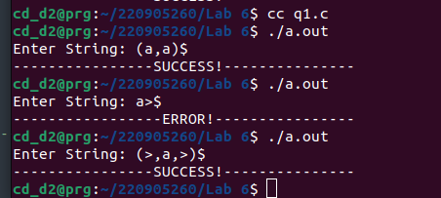

2. S →UVW
U →(S) | aSb | d
V → aV | 𝜖
W → cW | 𝜖

/*
S→UVW
U →(S) | aSb | d
V → aV | 𝜖
W → cW | 𝜖
*/
#include <stdio.h>
#include <stdlib.h>
#include <string.h>
int curr = 0;
char str[100];
void S();
void V();
void U();
void W();
void invalid()
{
printf("-----------------ERROR!----------------\n");
exit(0);
}
void valid()
{
printf("----------------SUCCESS!---------------\n");
exit(0);
}
void U()
{
if(str[curr]=='(')
{
curr++;
S();
if(str[curr] == ')')
{
curr++;
return;
}
else
invalid();
}
else if(str[curr]=='a')
{
curr++;
S();
if(str[curr] == 'b')
{
curr++;
return;
}
else
invalid();
}
else if(str[curr]=='d')
{
curr++;
return;
}
else
{
invalid();
}
}
void V()
{
if(str[curr]=='a')
{
curr++;
V();
}
}
void W()
{
if(str[curr]=='c')
{
curr++;
W();
}
}
void S()
{
U();
V();
W();
}
int main()
{
printf("Enter String: ");
scanf("%s", str);
S();
if(str[curr] == '$')
valid();
else
// printf("%c\n", str[curr]);
invalid();
}

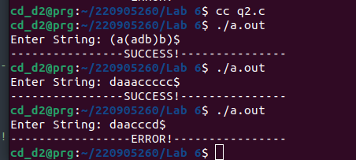

3. S→aAcBe
A→Ab|b
B→d

/*
S→aAcBe
A→Ab|b
B→d
*/
/*
S -> aAcBe
A -> bA'
A'-> bA' | 𝜖
B -> d
*/

#include <stdio.h>
#include <stdlib.h>
#include <string.h>
int curr = 0;
char str[100];
void S();
void A();
void Aprime();
void B();
void invalid()
{
printf("-----------------ERROR!----------------\n");
exit(0);
}
void valid()
{
printf("----------------SUCCESS!---------------\n");
exit(0);
}
void S()
{
if(str[curr]=='a')
{
curr++;
A();
if(str[curr]=='c')
{
curr++;
B();
if(str[curr]=='e')
{
curr++;
return;
}
else
{
invalid();
}
}
else
{
invalid();
}
}
else
{
invalid();
}
}
void A()
{
if(str[curr]=='b')
{
curr++;
Aprime();
}
else
{
invalid();
}
}
void Aprime()
{
if(str[curr]=='b')
{
curr++;
Aprime();
}
}
void B()
{
if(str[curr]=='d')
{
curr++;
return;
}
}
int main()
{
printf("Enter String: ");
scanf("%s", str);
S();
if(str[curr] == '$')
valid();
else
// printf("%c\n", str[curr]);
invalid();
}

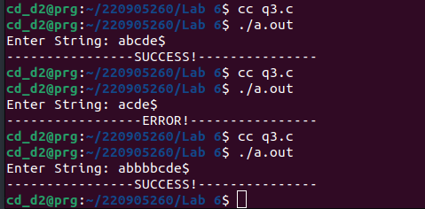

4. S →(L) | a
L → L,S | S

/*
S →(L) | a
L → L,S | S
*/
/*
S -> (L) | a
L -> SL'
L'-> ,SL' | 𝜖
*/

#include <stdio.h>
#include <stdlib.h>
#include <string.h>
int curr = 0;
char str[100];
void S();
void L();
void Lprime();
void invalid()
{
printf("-----------------ERROR!----------------\n");
exit(0);
}
void valid()
{
printf("----------------SUCCESS!---------------\n");
exit(0);
}
void L()
{
S();
Lprime();
}
void Lprime()
{
if(str[curr]==',')
{
curr++;
S();
Lprime();
}
}
void S()
{
if(str[curr]=='(')
{
curr++;
L();
if(str[curr]==')')
{
curr++;
return;
}
else
{
invalid();
}
}
else if(str[curr]=='a')
{
curr++;
return;
}
else
{
invalid();
}
}
int main()
{
printf("Enter String: ");
scanf("%s", str);
S();
if(str[curr] == '$')
valid();
else
// printf("%c\n", str[curr]);
invalid();
}

